Name : Youssef Kamel Ahmed Kamel

Group : 8

Section :48

B.N : 14

Topic : Artificial Intelligence

Brief : Artificial Intelligence Is Important And will be very Useful In The Future And will Be Used In Many Field And Its Engineers Comes From Mechatronics Engineering Department

Github Link : <https://github.com/YoussefKamel123/HTML_Project>

Github Page (published-Website) : <https://youssefkamel123.github.io/HTML_Project/deifination%20of%20artificial%20intelligence.html>

ScreenShots :

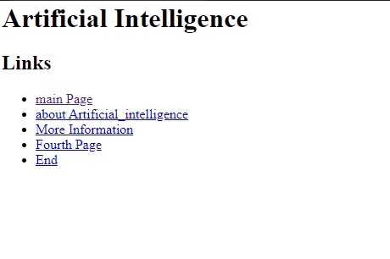

Source Code :

